**CSA0562- DBMS**

# SQL PROGRAMMING PROJECT LOGICAL MODEL:

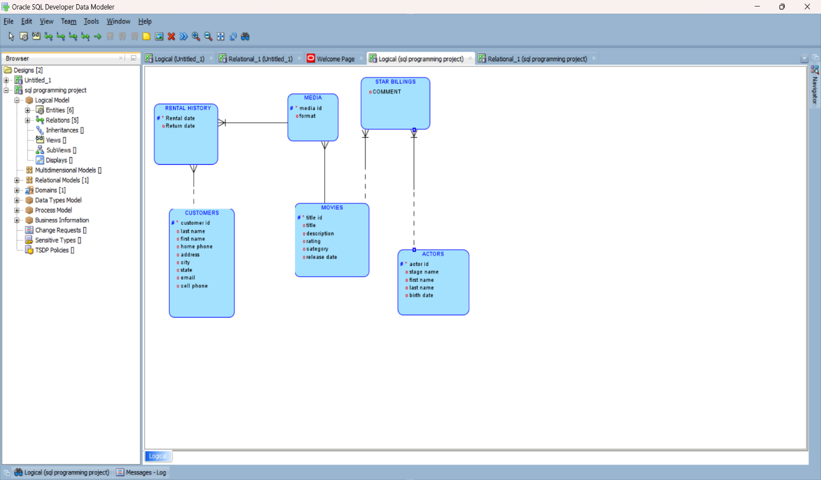

# RELATIONAL MODEL:

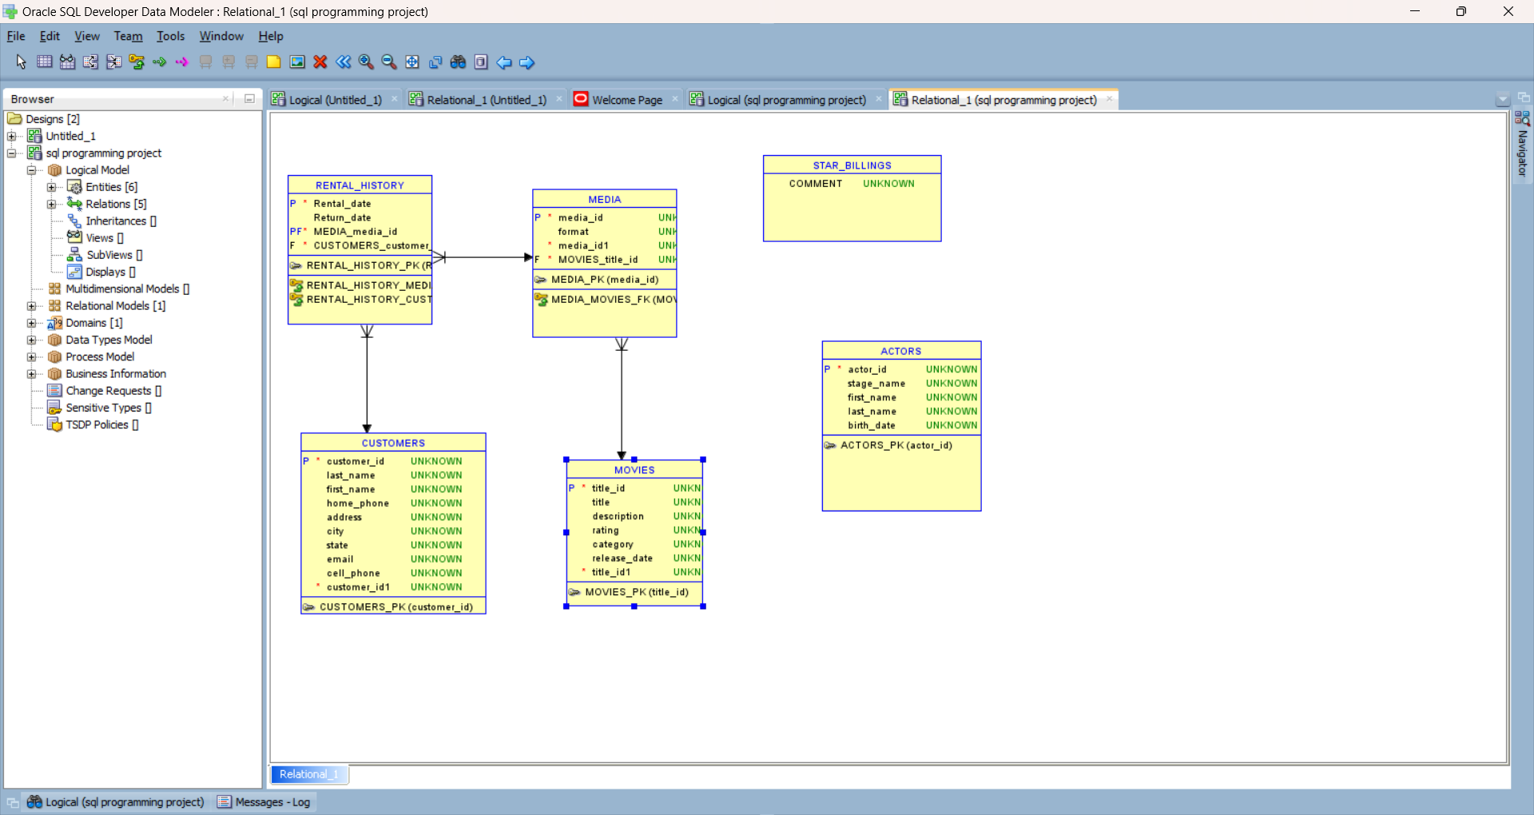

DDL QUERY:

